SCHOOL OF TECHNOLOGY | 

DATABASE MANAGEMENT SYSTEMS
PROJECT-BASED LEARNING (PBL) REPORT
Small Database Application Development using Java / Python

PROJECT TITLE
PROJECT 34 - DESIGN AND IMPLEMENTATION OF A DATABASE MANAGEMENT SYSTEM FOR ONLINE COURSE LEARNING PROGRESS MANAGEMENT SYSTEM

Program | B.tech - CSE AIML
Section | Rhinos
Faculty | Prof. Sahithi
Date of Submission | 11/10/2026
Academic Year | 2026 – 27

Submitted by
Roll Number | Student Name | Mobile | Email ID
25WU0102110 | Joy Peswani | 6264292332 | Joypeswani@gmail.com

ACKNOWLEDGEMENT
I express my sincere gratitude to Woxsen University, School of Technology, for providing me with the opportunity to undertake this Project-Based Learning (PBL) activity as part of the Database Management Systems (DBMS) course.
I thank my course faculty, Prof. Sahithi, for the guidance, suggestions, and support throughout the design and development of this project. The guidance helped me understand the practical application of database concepts such as ER modelling, relational schema design, normalization, SQL, constraints, queries, and database application development.
This PBL activity has strengthened my understanding of DBMS concepts and provided valuable experience in applying them to a real-world problem.

UNDERTAKING
I hereby declare that the project entitled "Design and Implementation of a Database Management System for Online Course Learning Progress Management System", submitted as part of the Project-Based Learning activity for the Database Management Systems (DBMS) course, is my individual work carried out under the guidance of the course faculty.
I undertake that the project report, database design, SQL scripts, application source code, results, and supporting materials submitted by me have been prepared for academic purposes. Wherever information, ideas, tools, datasets, or other resources have been referred to, appropriate acknowledgement has been provided.
I further undertake that I am responsible for the correctness and authenticity of the work submitted and that I have followed the academic and project guidelines prescribed by the University.

 |  |  |  | Signature
Date | : | 11/10/2026 | Name: | Joy Peswani
Place | : | Hyderabad | Roll Number: | 25WU0102110
 |  |  | Program: | B.tech AIML Rhinos

TABLE OF CONTENTS
Contents | Page No.
Abstract | 8
LIST OF TABLES | 5
LIST OF FIGURES | 6
LIST OF ACRONYMS | 7
1. PROBLEM STATEMENT, SOLUTION STRATEGY AND ER DIAGRAM | 9
1.1 Problem Statement | 9
1.2 Objectives | 9
1.3 Scope and Assumptions | 9
1.4 Proposed Solution Strategy | 10
1.5 Functional Requirements | 10
1.6 Entity-Relationship Diagram (ERD) | 11
1.7 Entity and Relationship Summary | 12
2. LOGICAL DATABASE DESIGN | 13
2.1 Relational Schema | 13
2.2 Keys and Integrity Constraints | 13
2.3 Functional Dependencies | 14
2.4 Normalization up to Third Normal Form (3NF) | 15
2.5 Data Dictionary | 16
2.6 Implementation of Logical Design: DDL and Sample Data | 17
3. APPLICATION DEVELOPMENT USING LOGICAL DATABASE DESIGN | 19
3.1 Application Overview | 19
3.2 Development Environment and Database Connectivity | 19
3.3 Application Modules and Database Mapping | 19
3.4 CRUD Operations | 20
3.5 Business Rules, Validation and Error Handling | 20
3.6 Reports and Database Operations | 21
3.7 Application Screens | 22
3.8 Testing and Results | 27
4. CONCLUSION | 29
4.1 Limitations and Future Enhancements | 29
5. REFERENCES | 30
6. APPENDICES | 31

LIST OF TABLES
Table No. | Table Title | Page No.
Table 1 | Scope and Assumptions | 10
Table 2 | Proposed Solution Strategy | 10
Table 3 | Functional Requirements | 10
Table 4 | Entity and Relationship Summary | 12
Table 5 | Relational Schema | 13
Table 6 | Keys and Integrity Constraints | 13
Table 7 | Normalization Status up to 3NF | 15
Table 8 | Data Dictionary | 16
Table 9 | Database Implementation Environment | 17
Table 10 | Database Objects: Triggers, Procedures, Views and Indexes | 17
Table 11 | Sample Data Volume | 18
Table 12 | Application Development Environment | 19
Table 13 | Application Module-to-Database Mapping | 19
Table 14 | CRUD Operations | 20
Table 15 | Business Rules, Validation and Error Handling | 21
Table 16 | Reports and Database Operations | 21
Table 17 | Test Cases | 27

LIST OF FIGURES
Figure No. | Figure Title | Page No.
Figure 1 | Entity-Relationship Diagram of the Proposed System | 11
Figure 2 | Learner mode: My Learning dashboard with live progress from the database | 22
Figure 3 | Learner mode: course catalog and enrolment | 22
Figure 4 | Learner mode: My Certificates | 23
Figure 5 | Instructor mode: studio dashboard | 23
Figure 6 | Instructor mode: course lessons with edit and delete | 24
Figure 7 | Instructor mode: student progress tracking | 24
Figure 8 | Admin mode: dashboard with KPI cards and charts | 25
Figure 9 | Admin mode: table browser with CRUD on the users table | 25
Figure 10 | Admin mode: create course form with validation | 26
Figure 11 | Admin mode: reports and analytics | 26
Figure 12 | Admin mode: read-only SQL console | 27
Figure 13 | Admin mode: printable certificate of completion | 27
Figure 14 | Instructor mode: studio unlock dialog (profile and password) | 32
Figure 15 | Admin mode: unlock dialog | 32
Figure 16 | Instructor mode: quiz questions with options A to D and correct key | 32
Figure 17 | Admin mode: recent enrolments, certificates and top completers | 33
Figure 18 | Admin mode: add question form with four options | 33
Figure 19 | Admin mode: assessment and question builder | 34
Figure 20 | Admin mode: certificate registry with search and print | 34

LIST OF ACRONYMS
Acronym | Expansion
1NF | First Normal Form
2NF | Second Normal Form
3NF | Third Normal Form
ACID | Atomicity, Consistency, Isolation, Durability
BCNF | Boyce-Codd Normal Form
CRUD | Create, Read, Update, Delete
CSV | Comma-Separated Values
DBMS | Database Management System
DDL | Data Definition Language
ER | Entity-Relationship
ERD | Entity-Relationship Diagram
FD | Functional Dependency
FK | Foreign Key
KPI | Key Performance Indicator
PBL | Project-Based Learning
PK | Primary Key
SQL | Structured Query Language

ABSTRACT
Online learning platforms must track course content, enrolments, lesson progress, quizzes, attempts, scores and certificates, but without structured data this progress becomes unreliable and learners and instructors cannot see what has actually been achieved. The objective of this project is to design and implement a normalized relational database and a working application that manage the complete online course learning lifecycle. The conceptual design was captured as an Entity-Relationship model and converted into a relational schema of 14 tables normalized up to Third Normal Form, with primary keys, foreign keys, UNIQUE, NOT NULL, CHECK and DEFAULT constraints, triggers, stored procedures with transactions, indexes and six SQL views. The database was implemented in MySQL 8 and populated with 871 sample rows. A Python Flask web application provides Learner, Instructor and password-protected Admin modes for course publishing, enrolment, lesson completion, quiz attempts, score calculation, progress tracking, certificate issue, full CRUD on every table, reports and a read-only SQL console. The database itself enforces the business rules of one enrolment per course, progress between 0 and 100, attempt limits, valid scores and completion-based certificates, and these rules were verified through positive and negative test cases. The result is a reliable, measurable and auditable record of each learner's journey.

KEYWORDS
Keywords: Relational Database, ER Diagram, Normalization (3NF), MySQL, Python Flask, Online Course Management

CHAPTER 1

PROBLEM STATEMENT, SOLUTION STRATEGY AND ER DIAGRAM

1.1 Problem Statement
Online learning platforms must keep track of a content hierarchy, enrolments, lesson progress, quizzes, attempts, scores and certificates. When this data is unstructured, learners struggle to track their performance, quiz attempts are inaccurate or lost, and learning pathways lack organisation and clarity. Without a centralised database, instructors find it difficult to assess student progress, and administrators cannot monitor the platform reliably.
This disorganisation leads to frustration and disengagement among learners, because they cannot see their achievements or the areas that need improvement. A structured relational database is therefore needed to improve tracking, enable better feedback and make each learner's educational journey clear and measurable.

1.2 Objectives
The objectives of the project are:
- Design a normalized (3NF) relational database that tracks the full educational lifecycle of users, from course publishing to certification.
- Implement the database in MySQL with primary keys, foreign keys, UNIQUE, NOT NULL, CHECK and DEFAULT constraints, triggers and views.
- Automate attempt tracking and score calculation for quizzes within an attempt limit.
- Generate certificates automatically only when a learner completes all lessons and passes the quizzes.
- Develop a Python application with Learner, Instructor and Admin modes that supports CRUD operations, validation, reports and error handling on the same database.

1.3 Scope and Assumptions
The scope, exclusions and assumptions of the project are given in Table 1.
Table 1. Scope and Assumptions
Item | Description
In Scope | Course hierarchy (courses, modules, lessons); instructors and learners; enrolments; lesson progress; quizzes, questions, attempts, responses and scores; certificates and learner feedback; Learner, Instructor and Admin modes; reports for learner progress, course completion, dropout, quiz performance, certificate eligibility and instructor summaries.
Out of Scope / Exclusions | Online payment, video hosting or streaming, individual hashed-password logins, e-mail notifications, report export to PDF and deployment on a production web server.
Assumptions | One MySQL 8 database is shared by all three modes; each course is owned by one instructor; quizzes are multiple-choice with options A to D; each quiz allows a limited number of attempts (default 3); the application runs locally and mode passwords are kept in a configuration file outside the page code.

1.4 Proposed Solution Strategy
The solution is a three-layer system: a browser front end, a Python Flask application and a MySQL 8 database that enforces the business rules. The conceptual model is drawn as an ER diagram and mapped to relations using the standard ER-to-relational rules [1], then normalized to 3NF. The three user roles and their modules, the workflow, the key business rules and the expected outputs are summarised in Table 2.
Table 2. Proposed Solution Strategy
Solution Element | Project-Specific Description
Primary Users / Roles | Learners enrol in courses, study lessons, take quizzes and view certificates. Instructors publish courses, modules, lessons and quizzes and watch student progress. Administrators monitor metrics, manage every table, run reports and oversee certificate issue.
Major Application Modules | Learner mode (catalog, my learning, quizzes, certificates); Instructor studio (courses, modules, lessons, quizzes, questions, student progress, feedback); Admin mode (dashboard, table browser with CRUD, reports, SQL console, certificate registry).
Proposed Workflow | Instructor publishes a course, then a learner enrols, completes lessons (progress 0-100), attempts quizzes within the attempt limit, and a certificate is issued once all lessons and quizzes are complete.
Important Business Rules | One enrolment per learner per course; progress between 0 and 100; hard cap on quiz attempts; scores must be valid and not exceed the total marks; certificates only for completed courses.
Expected Reports / Outputs | Learner progress, course completion rate, dropout report, quiz performance, certificate eligibility, instructor summary, printable certificates and CSV export.

1.5 Functional Requirements
The functional requirements of the system are listed in Table 3.
Table 3. Functional Requirements
Req. ID | Functional Requirement | Priority
FR-01 | Instructors shall publish courses made of modules and lessons, and attach quizzes with questions. | High
FR-02 | Learners shall browse and search the published course catalog and enrol in a course; a second enrolment in the same course shall be rejected. | High
FR-03 | The system shall track lesson completion for every enrolment as a progress value from 0 to 100. | High
FR-04 | Learners shall attempt quizzes within the attempt limit and the system shall record each response. | High
FR-05 | The system shall calculate the score of each attempt from the responses and reject invalid scores. | High
FR-06 | The system shall issue a certificate with a unique code only when all lessons and quizzes are complete. | High
FR-07 | Learners shall be able to give feedback (rating 1 to 5) on a course. | Medium
FR-08 | Administrators shall create, view, edit, delete and search records in every table. | High
FR-09 | The system shall provide reports on learner progress, course completion, dropout, quiz performance, certificate eligibility and instructor summary, with CSV export. | High
FR-10 | Instructor and Admin modes shall be protected by a password checked on the server, and the SQL console shall be read-only. | Medium

1.6 Entity-Relationship Diagram (ERD)
Figure 1 shows the ER diagram approved in Review 1 for the principal entities: Instructor, Course, Lesson, Quiz, Enrolment and Learner, with their key attributes and cardinalities (an instructor teaches many courses, a course has many lessons and many enrolments, and a learner makes many enrolments). During logical design the model was completed with the entities modules, questions, responses, attempts, lesson progress, certificates, feedback and users, and the quiz was attached to a course; the complete set of entities and relationships is listed in Table 4.
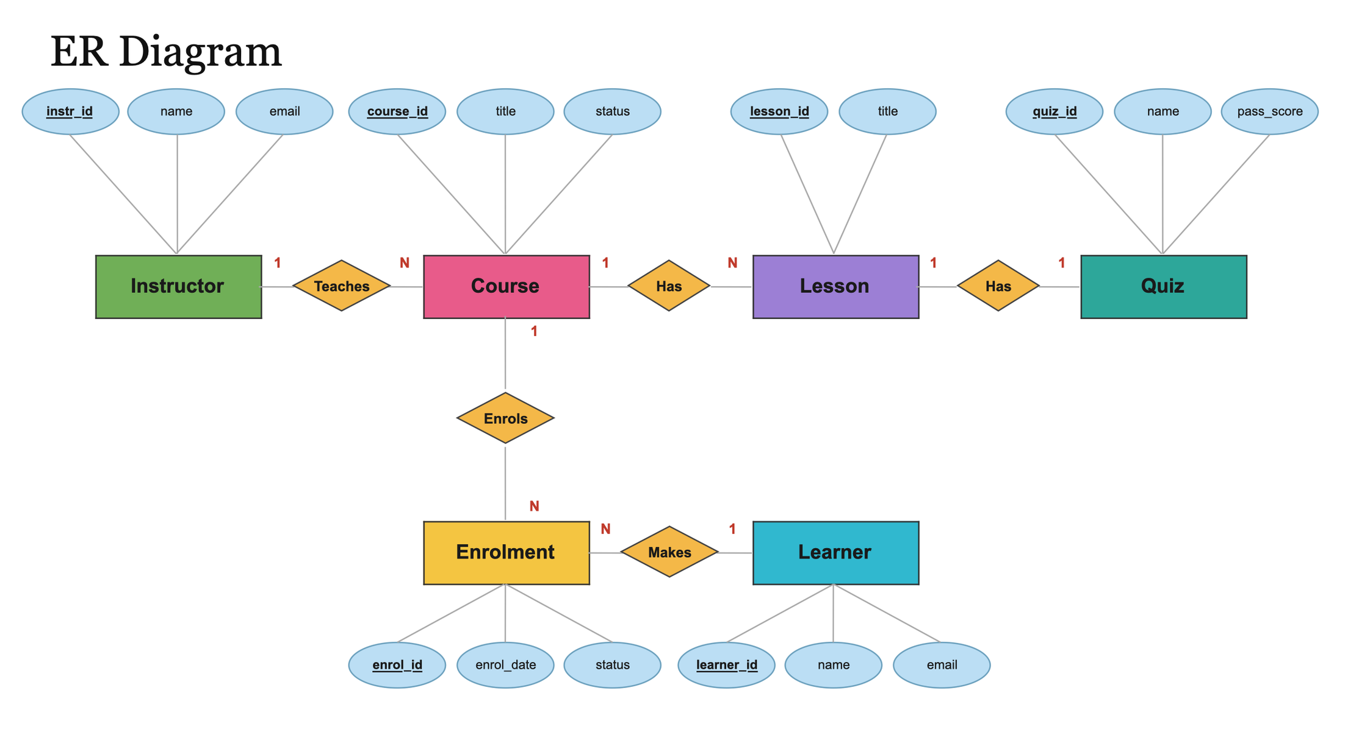
Figure 1. Entity-Relationship Diagram of the Proposed System

1.7 Entity and Relationship Summary
Table 4. Entity and Relationship Summary
Entity / Relationship | Major Attributes / Cardinality | Purpose / Rule
Instructor (teaches Course) | instr_id (PK), name, email; 1:N with Course | A person who creates and publishes courses.
Learner (makes Enrolment) | learner_id (PK), name, email; 1:N with Enrolment | A person who enrols in courses and takes quizzes; email must be unique.
Course (has Lesson, enrols) | course_id (PK), title, status, instr_id (FK); 1:N with Module/Lesson and Enrolment | Unit of content; status is draft, published or archived.
Module | module_id (PK), course_id (FK), title; N:1 with Course | Groups lessons of a course into a hierarchy (course > module > lesson).
Lesson | lesson_id (PK), title, module_id (FK), duration, lesson_order | Smallest learning unit; order is unique within a module.
Quiz | quiz_id (PK), name, pass_score, max_attempts, course_id (FK); 1:N with Question | Assessment of a course with a pass mark and an attempt cap.
Question / Response | question_id (PK), options A-D, correct option, marks; response_id (PK) per attempt and question | Each question carries marks; each answer given in an attempt is stored as its own row.
Enrolment | enrol_id (PK), learner_id (FK), course_id (FK), enrol_date, status; N:1 with Learner and Course | Joins a learner to a course; exactly one per learner and course; status Active, Completed or Dropped.
Lesson Progress | progress_id (PK), enrol_id (FK), lesson_id (FK), progress_pct; N:1 with Enrolment | Tracks the completion (0-100) of one lesson within one enrolment.
Attempt | attempt_id (PK), enrol_id (FK), quiz_id (FK), attempt_no, score; N:1 with Enrolment and Quiz | One try of a quiz; limited by max_attempts.
Certificate | certificate_id (PK), enrol_id (FK), certificate_code, issued_on; 1:1 with Enrolment | Issued once on completion, identified by a unique code.
Feedback | feedback_id (PK), enrol_id (FK), rating, comments; N:1 with Enrolment | Learner rating and comment for a course.
User | user_id (PK), role (admin, instructor, learner); 1:1 with Instructor / Learner | Account record for the 26 platform users (1 admin, 5 instructors, 20 learners).

CHAPTER 2

LOGICAL DATABASE DESIGN

2.1 Relational Schema
The ER model was mapped to 14 relations, listed in Table 5, in four groups: People, Content, Assessment and Tracking. Each 1:N relationship became a foreign key on the 'many' side, and the enrolment between a learner and a course became its own relation that is referenced by lesson progress, attempts, certificates and feedback.
Table 5. Relational Schema
S.No. | Table Name | Purpose
1 | users | People: login accounts with a role (admin, instructor or learner).
2 | instructors | People: instructor profile that owns courses.
3 | learners | People: learner profile with unique e-mail.
4 | courses | Content: course with title, category, level, price, status and owning instructor.
5 | modules | Content: module belonging to a course.
6 | lessons | Content: lesson belonging to a module, with duration and order.
7 | quizzes | Assessment: quiz of a course with pass marks and maximum attempts.
8 | questions | Assessment: multiple-choice question of a quiz with options A-D, correct option and marks.
9 | enrolments | Tracking: enrolment of a learner in a course with its status.
10 | lesson_progress | Tracking: completion percentage of a lesson for an enrolment.
11 | attempts | Assessment: quiz attempt of an enrolment with attempt number and score.
12 | responses | Assessment: answer given to each question within an attempt.
13 | certificates | Tracking: certificate issued for a completed enrolment.
14 | feedback | Tracking: rating and comments given by a learner on an enrolment.

2.2 Keys and Integrity Constraints
Table 6 lists the keys and the integrity constraints used to enforce the business rules of one enrolment per course, progress within 0-100, attempt limits, valid scores and completion criteria.
Table 6. Keys and Integrity Constraints
Table Name | Key / Constraint | Attribute(s) | Business Rule Enforced
learners | Primary Key / UNIQUE | learner_id; email | Every learner is identified once; e-mail is unique and format-checked.
instructors | Primary Key | instructor_id | Unique instructor profile.
courses | Primary / Foreign Key | course_id; instructor_id -> instructors | Every course belongs to exactly one existing instructor.
courses | Default | status | Defaults to 'draft'; allowed values draft, published, archived.
modules | Primary / Foreign Key | module_id; course_id -> courses | Modules always belong to a course.
lessons | Primary / Foreign Key / UNIQUE | lesson_id; module_id -> modules; (module_id, lesson_order) | Lesson order is unique inside a module.
quizzes | Check / Default | max_attempts | CHECK > 0, DEFAULT 3: hard cap on attempts per quiz.
questions | Not Null / Foreign Key | correct_option; quiz_id -> quizzes | Every question has an answer key A to D.
enrolments | Primary / Foreign Key | enrolment_id; learner_id, course_id | Links an existing learner to an existing course.
enrolments | UNIQUE | (learner_id, course_id) | One enrolment per course.
enrolments | Not Null / Default | status; enrol_date | Status DEFAULT 'Active' (Active, Completed, Dropped); enrol_date defaults to today.
lesson_progress | Primary / Foreign Key / UNIQUE | progress_id; enrolment_id, lesson_id; (enrolment_id, lesson_id) | One progress row per lesson per enrolment.
lesson_progress | Check / Default | progress_pct | CHECK between 0 and 100, DEFAULT 0.
attempts | Primary / Foreign Key / UNIQUE | attempt_id; enrolment_id, quiz_id; (enrolment_id, quiz_id, attempt_no) | Each attempt number is used once per enrolment and quiz.
attempts | Check + Trigger | score; attempt_no | CHECK score >= 0; triggers block attempts beyond max_attempts and scores above the total marks.
responses | Primary / Foreign Key | response_id; attempt_id, question_id | A response belongs to one attempt and one question.
certificates | Primary / Foreign Key / UNIQUE | certificate_id; enrolment_id; certificate_code | One certificate per enrolment, each with a unique code.
certificates | Trigger | enrolment_id | Certificate is blocked unless the course is completed and the quizzes are passed.
feedback | Primary / Foreign Key / Check | feedback_id; enrolment_id; rating | CHECK rating between 1 and 5.

2.3 Functional Dependencies
The important functional dependencies used to justify the normalization are listed below. In every relation each determinant is a candidate key.
enrolments: enrolment_id -> learner_id, course_id, enrol_date, status
(learner_id, course_id) -> enrolment_id
lessons: lesson_id -> module_id, title, duration, lesson_order
(module_id, lesson_order) -> lesson_id
courses: course_id -> title, category, level, price, status, instructor_id
attempts: attempt_id -> enrolment_id, quiz_id, attempt_no, score
(enrolment_id, quiz_id, attempt_no) -> attempt_id
lesson_progress: progress_id -> enrolment_id, lesson_id, progress_pct
(enrolment_id, lesson_id) -> progress_id
certificates: certificate_id -> enrolment_id, certificate_code, issued_on
enrolment_id -> certificate_id; certificate_code -> certificate_id

Every determinant listed above is a candidate key of its relation, so there are no partial or transitive dependencies and each relation satisfies 3NF (and BCNF).

2.4 Normalization up to Third Normal Form (3NF)
First Normal Form (1NF). Every column holds a single atomic value. Quiz options are stored in separate columns option_a to option_d and each answer given by a learner is stored as its own row in the responses table rather than as a list inside an attempt.
Second Normal Form (2NF). Every non-key column depends on the whole key. Enrolment details such as the learner, course, date and status are stored once in enrolments and are not repeated in lesson_progress or attempts, which only refer to the enrolment through its key.
Third Normal Form (3NF). There are no transitive dependencies. Instructor details live only in instructors and are referenced by instructor_id from courses, and course progress is calculated by views instead of being stored twice.
The Review 1 schema had 8 tables. To reach 3NF and to cover the full project brief it was decomposed and extended to 13 tables in Review 2 (modules, questions, responses, certificates and feedback were added) and to 14 tables in the final system (a users table supports the Admin, Instructor and Learner roles). Because every determinant of every relation is a candidate key, all relations also satisfy BCNF.
Table 7 records the normal forms satisfied by every relation. Normalization theory follows [1], [2].
Table 7. Normalization Status up to 3NF
Relation Name | 1NF | 2NF | 3NF | BCNF | Remarks / Decomposition
users | Yes | Yes | Yes | Yes | Single-column key; role attributes depend only on user_id.
instructors | Yes | Yes | Yes | Yes | Instructor details stored once and referenced from courses.
learners | Yes | Yes | Yes | Yes | learner_id and unique email are the only determinants.
courses | Yes | Yes | Yes | Yes | Instructor data separated into instructors (no transitive dependency).
modules | Yes | Yes | Yes | Yes | Separated from lessons to give the course > module > lesson hierarchy.
lessons | Yes | Yes | Yes | Yes | Key lesson_id; (module_id, lesson_order) is a candidate key.
quizzes | Yes | Yes | Yes | Yes | Pass marks and max attempts depend only on quiz_id.
questions | Yes | Yes | Yes | Yes | Options A to D are atomic columns; correct option depends on question_id.
enrolments | Yes | Yes | Yes | Yes | Candidate keys enrolment_id and (learner_id, course_id).
lesson_progress | Yes | Yes | Yes | Yes | Enrolment details not repeated; progress_pct depends on progress_id.
attempts | Yes | Yes | Yes | Yes | Score and attempt number depend on attempt_id; enrolment data not repeated.
responses | Yes | Yes | Yes | Yes | Each response is its own row (atomic values).
certificates | Yes | Yes | Yes | Yes | Candidate keys certificate_id, enrolment_id and certificate_code.
feedback | Yes | Yes | Yes | Yes | Rating and comments depend on feedback_id only.

2.5 Data Dictionary
Table 8 describes the key columns of every table, with their data types, constraints and meaning.
Table 8. Data Dictionary
Table | Attribute | Data Type | Key / Constraint | Description
users | user_id | INT | PK, AUTO_INCREMENT | Unique identifier of a platform user
users | role | ENUM | NOT NULL | admin, instructor or learner
instructors | instructor_id | INT | PK, AUTO_INCREMENT | Unique identifier of an instructor
instructors | name, email | VARCHAR | NOT NULL | Instructor name and contact address
learners | learner_id | INT | PK, AUTO_INCREMENT | Unique identifier of a learner
learners | name | VARCHAR(100) | NOT NULL | Learner name
learners | email | VARCHAR(100) | UNIQUE, NOT NULL, CHECK format | Login and contact address
courses | course_id | INT | PK, AUTO_INCREMENT | Unique identifier of a course
courses | title, category, level | VARCHAR / ENUM | NOT NULL | Course title, category and difficulty level
courses | price | DECIMAL | DEFAULT 0 | Course fee (free courses allowed)
courses | status | ENUM | DEFAULT 'draft' | draft, published or archived
courses | instructor_id | INT | FK -> instructors, NOT NULL | Instructor who owns the course
modules | module_id, course_id | INT, INT | PK; FK -> courses | Module and the course it belongs to
lessons | lesson_id, module_id | INT, INT | PK; FK -> modules | Lesson and its module
lessons | title, duration, lesson_order | VARCHAR, INT, INT | NOT NULL; UNIQUE (module_id, lesson_order) | Lesson title, length and position
quizzes | quiz_id, course_id | INT, INT | PK; FK -> courses | Quiz and its course
quizzes | pass_marks | INT | NOT NULL | Marks needed to pass
quizzes | max_attempts | INT | CHECK > 0, DEFAULT 3 | Attempt cap per quiz
questions | question_id, quiz_id | INT, INT | PK; FK -> quizzes | Question and its quiz
questions | option_a to option_d | VARCHAR | NOT NULL | Four answer options
questions | correct_option | ENUM('A'..'D') | NOT NULL | Answer key
questions | marks | INT | NOT NULL (20 in sample data) | Marks carried by the question
enrolments | enrolment_id | INT | PK, AUTO_INCREMENT | Unique identifier of an enrolment
enrolments | learner_id, course_id | INT, INT | UNIQUE pair, both FK | One enrolment per course
enrolments | enrol_date | DATE | DEFAULT CURRENT_DATE | Date of enrolment
enrolments | status | ENUM | NOT NULL, DEFAULT 'Active' | Active, Completed or Dropped
lesson_progress | progress_id | INT | PK, AUTO_INCREMENT | Unique identifier of a progress record
lesson_progress | enrolment_id, lesson_id | INT, INT | FK; UNIQUE pair | Enrolment and lesson being tracked
lesson_progress | progress_pct | TINYINT | CHECK 0 to 100, DEFAULT 0 | Completion of one lesson
attempts | attempt_id | INT | PK, AUTO_INCREMENT | Unique identifier of an attempt
attempts | enrolment_id, quiz_id | INT, INT | FK -> enrolments, quizzes | Who attempted which quiz
attempts | attempt_no | INT | UNIQUE with (enrolment_id, quiz_id); trigger vs max_attempts | Sequence number of the attempt
attempts | score | INT | CHECK >= 0, trigger <= total marks | Marks earned in an attempt
responses | response_id, attempt_id, question_id | INT, INT, INT | PK; FK -> attempts, questions | Answer given to a question in an attempt
certificates | certificate_id | INT | PK, AUTO_INCREMENT | Unique identifier of a certificate
certificates | enrolment_id | INT | FK, UNIQUE | Completed enrolment being certified
certificates | certificate_code, issued_on | VARCHAR, DATE | UNIQUE code; NOT NULL | Verification code and issue date
feedback | feedback_id, enrolment_id | INT, INT | PK; FK -> enrolments | Feedback and its enrolment
feedback | rating | TINYINT | CHECK 1 to 5 | Learner rating

2.6 Implementation of Logical Design: DDL and Sample Data
The database was implemented in MySQL 8 [3]; Table 9 gives the implementation details. The triggers, stored procedures, views and indexes are summarised in Table 10, and Table 11 gives the volume of sample data. A representative DDL fragment is shown below; the complete script is submitted with the report (Appendix A).
Table 9. Database Implementation Environment
Item | Details
DBMS | MySQL
DBMS Version | MySQL 8
Database Name | course_progress_db
Number of Tables | 14 tables and 6 views
Sample Data | 871 rows across 14 tables (26 users, 5 instructors, 20 learners, 9 courses, 36 enrolments, 9 quizzes, 41 questions, 48 attempts)

Table 10. Database Objects: Triggers, Procedures, Views and Indexes
Database Object | Description
Triggers | Block a quiz attempt beyond max_attempts; reject a score above the total marks; block a certificate unless the course is completed and all quizzes are passed.
Stored procedures | enroll_learner, submit_quiz_attempt, complete_lesson and issue_certificate. Each runs in a transaction (START TRANSACTION, COMMIT, ROLLBACK) with error handlers.
Views | vw_learner_progress, vw_course_completion, vw_dropout_report, vw_quiz_performance, vw_certificate_eligibility, vw_instructor_summary.
Indexes | learner e-mail, course title and status, enrolment (learner, course), attempt (enrolment, quiz).

CREATE TABLE enrolments (
enrolment_id INT AUTO_INCREMENT PRIMARY KEY,
learner_id INT NOT NULL,
course_id INT NOT NULL,
enrol_date DATE DEFAULT (CURRENT_DATE),
status ENUM('Active','Completed','Dropped')
NOT NULL DEFAULT 'Active',
UNIQUE (learner_id, course_id),
FOREIGN KEY (learner_id) REFERENCES learners(learner_id),
FOREIGN KEY (course_id) REFERENCES courses(course_id)
);

CREATE TABLE lesson_progress (
...
progress_pct TINYINT NOT NULL DEFAULT 0
CHECK (progress_pct BETWEEN 0 AND 100)
);

The sample data uses realistic names, courses and quizzes. Enrolments cover every status (Active, Completed and Dropped), and lesson progress, quiz attempts with responses, certificates and feedback are spread over several months so that every report returns meaningful rows. Attempts to insert duplicate enrolments, progress above 100 or extra quiz attempts are rejected by the constraints.
Table 11. Sample Data Volume
Table | Rows | Table | Rows
users | 26 | lesson_progress | 321
instructors | 5 | quizzes | 9
learners | 20 | questions | 41
courses | 9 | attempts | 48
modules | 25 | responses | 228
lessons | 74 | certificates | 11
enrolments | 36 | feedback | 18

CHAPTER 3

APPLICATION DEVELOPMENT USING LOGICAL DATABASE DESIGN

3.1 Application Overview
The application, named LearnPulse, is a Python Flask web application connected to the MySQL database course_progress_db. It has three modes. Learner mode lets a learner browse the catalog, enrol, track lessons, take quizzes within the attempt limit and view certificates. Instructor mode is a password-protected studio where an instructor manages only their own courses, modules, lessons, quizzes and questions and follows student progress. Admin mode is password-protected and gives a dashboard, full CRUD on every table, six reports with CSV export, a read-only SQL console and a certificate registry. All modes read and write the same tables, so the application always uses the logical database design rather than static data.

3.2 Development Environment and Database Connectivity
Architecture: the browser sends requests to Flask routes for each mode [4]; the routes validate the form input, check the session and passwords and call the database. Database login and mode passwords are kept in a .env file, outside the page code. Table 12 lists the development environment.
Table 12. Application Development Environment
Item | Details
Programming Language | Python 3
DBMS | MySQL 8 (database course_progress_db)
IDE / Framework / GUI Toolkit | Flask web framework; HTML front end opened in the browser (application name: LearnPulse)
Database Connector / Driver | [confirm MySQL driver used, e.g. mysql-connector-python]
Operating Environment | Local application on port 5001, started from a start script; database login and mode passwords are kept in a .env file
Repository Link | [GitHub / repository link]

3.3 Application Modules and Database Mapping
Table 13 maps each application module to the tables it uses and the operations it performs.
Table 13. Application Module-to-Database Mapping
Module / Screen | Purpose | Tables Used | Main Operations
Learner: Catalog and Enrolment | Browse and search published courses and enrol | courses, instructors, enrolments | Read, search; enroll_learner (Create); duplicate enrolment rejected
Learner: My Learning | Track lessons and course progress | enrolments, lessons, lesson_progress | Read; complete_lesson (Create / Update progress)
Learner: Quizzes | Attempt quizzes within the attempt limit and see the score | quizzes, questions, attempts, responses | Create attempt and responses; score calculation; attempt-limit trigger
Learner: Certificates | View and print certificates | certificates, enrolments, courses | Read; issue_certificate (Create)
Instructor Studio | Create and edit own courses, modules, lessons, quizzes and questions | courses, modules, lessons, quizzes, questions | Create, Read, Update, Delete (own courses only)
Instructor: Student Progress | See lessons done, quizzes passed and feedback per learner | enrolments, lesson_progress, attempts, feedback | Read with filter by student or course (vw_learner_progress)
Admin: Dashboard and Tracking | KPI cards, charts, recent enrolments and certificates, top completers | all tables and views | Read / aggregate
Admin: Table Browser | Search, sort, filter, add, view, edit and delete rows of any table | all 14 tables | Full CRUD; Schema and Indexes tab
Admin: Reports and SQL Console | Six report tabs with CSV export and a read-only SQL console | six SQL views | Read (SELECT only)
Admin: Certificate Registry | Search issued certificates and print them | certificates, learners, courses | Read, search, print

3.4 CRUD Operations
Table 14 shows how the four CRUD operations are provided by the application, with the screens that serve as evidence.
Table 14. CRUD Operations
Operation | Application Feature / Screen | Table(s) Affected | Evidence
Create | Enrol in a course; create a course; add a question; add a row in the table browser | enrolments, courses, questions, any table | Figure 3, Figure 10, Figure 9
Read / Search | Course catalog search; student progress filter; table browser search, sort and filter; reports | courses, enrolments, lesson_progress, six views | Figure 3, Figure 7, Figure 11
Update | Edit lessons, quizzes and questions in the Instructor studio; edit any row in the table browser | lessons, questions, any table | Figure 6, Figure 9
Delete / Controlled Removal | Delete lessons and questions; delete rows in the table browser; foreign keys protect linked data | lessons, questions, any table | Figure 6, Figure 9

3.5 Business Rules, Validation and Error Handling
The application prevents invalid input and rule violations at two levels. Form validation stops empty required fields before anything reaches the database, passwords are checked on the server, and the SQL console accepts only SELECT statements. The database then enforces the data rules through constraints and triggers, and the stored procedures use transactions with rollback on error, so a failed operation leaves no partial data. A database error is shown to the user as a clear message. Table 15 summarises the rules, how each is implemented and the evidence.
Table 15. Business Rules, Validation and Error Handling
Rule / Validation | How Implemented | Evidence / Message
One enrolment per course | UNIQUE (learner_id, course_id) on enrolments; enroll_learner procedure | Catalog shows 'Enrolled' and a second enrolment is rejected with a clear message
Progress from 0 to 100 | CHECK (progress_pct BETWEEN 0 AND 100) | Value 101 is rejected by the CHECK constraint
Attempt limit | Trigger on attempts compared with quizzes.max_attempts | Fourth attempt on a 3-try quiz is blocked
Valid scores | CHECK (score >= 0) and a trigger against the total marks (20 marks per question) | Invalid score is rejected; the scores shown come from the database
Certificate only when complete | Trigger checks lessons and quizzes before issue | Early certificate is blocked; learner appears in the pending eligibility queue
Required fields | Form validation in the Flask routes before any SQL runs | 'Please fill out this field' message on an empty course title
Mode passwords | Password checked on the server and read from .env | Wrong password: access denied
Safe SQL console | Only SELECT statements are executed | DROP, ALTER, UPDATE and DELETE are rejected and data is unchanged
Transactions | Stored procedures use START TRANSACTION, COMMIT and ROLLBACK with error handlers | A failed step leaves no partial enrolment, attempt or certificate

3.6 Reports and Database Operations
Reports are read from six SQL views, one for each report tab, and can be exported to CSV. Table 16 lists the reports with the SQL concept used; the main queries are given in Appendix A.
Table 16. Reports and Database Operations
Report / Operation | SQL / Database Concept Used | Application Output
Learner progress | JOIN of enrolments, learners, courses with LEFT JOIN on lesson_progress; vw_learner_progress | Lessons completed per learner per course with status (Figure 7)
Course completion | GROUP BY with SUM and COUNT; vw_course_completion | Enrolled, completed and completion percentage for every course (Figure 11)
Dropout report | Filtered join on enrolments with status 'Dropped'; vw_dropout_report | Learners who dropped each course (Reports tab)
Quiz performance | Aggregation (AVG, COUNT) over attempts; vw_quiz_performance | Pass rates and average scores per quiz (Reports tab, dashboard chart)
Certificate eligibility | Nested subquery with NOT IN and NOT EXISTS; vw_certificate_eligibility | Completed learners who passed all quizzes and have no certificate yet (Certification audit tab)
Instructor summary | Aggregation across courses, enrolments and feedback; vw_instructor_summary | Courses, students and average rating per instructor
SQL console / CSV export | Read-only SELECT with ready-made snippets | Live query results and CSV download (Figure 12)

3.7 Application Screens
The following screens show data entry, search and display, update, the project-specific transactions (enrolment, quiz attempt, certificate issue) and the reports. Additional screens are given in Appendix C.
Figure 2 - Progress bars and lesson counts come from the learner progress view; Completed and Active states match the enrolment status.

Figure 2. Learner mode: My Learning dashboard with live progress from the database
Figure 3 - Published courses can be searched and enrolled; an already enrolled course shows 'Enrolled' (one enrolment per course).
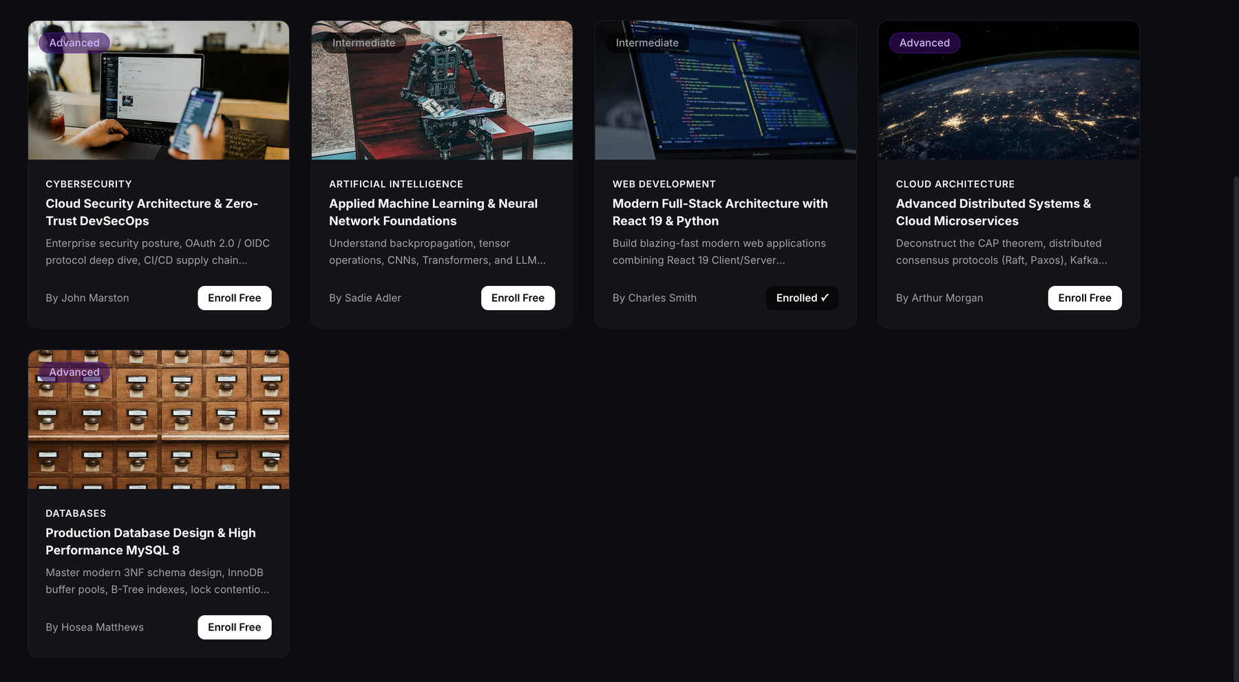
Figure 3. Learner mode: course catalog and enrolment
Figure 4 - Each certificate has a unique code and is issued only when lessons and quizzes are complete.
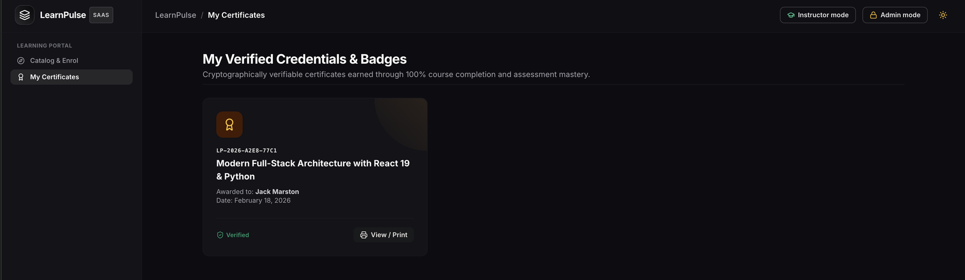
Figure 4. Learner mode: My Certificates
Figure 5 - Shows the instructor's courses, modules, lessons, students and average rating; instructors see only their own courses.
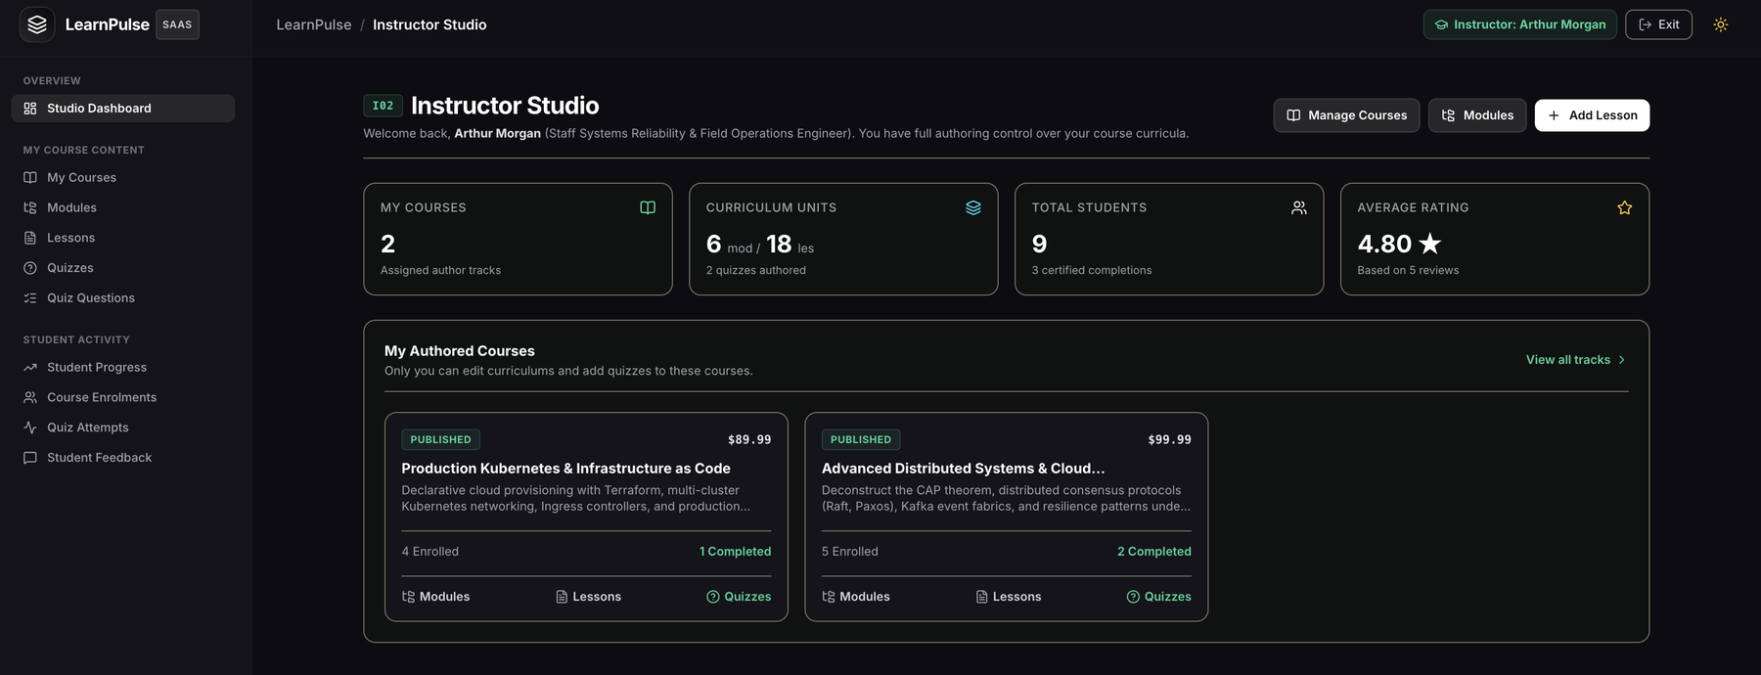
Figure 5. Instructor mode: studio dashboard
Figure 6 - Lessons are grouped by course and module with order and duration; each row can be edited or deleted.
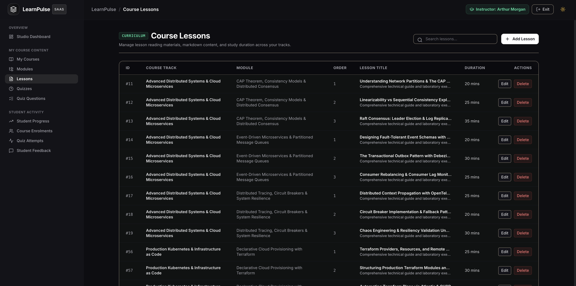
Figure 6. Instructor mode: course lessons with edit and delete
Figure 7 - The learner progress query shown in the application, with status (Active, Completed, Dropped), lessons done and quizzes passed.
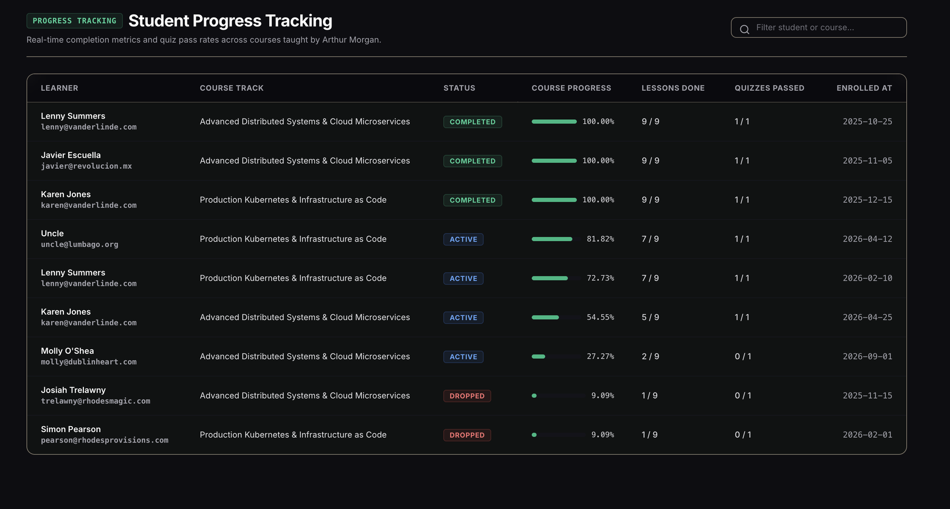
Figure 7. Instructor mode: student progress tracking
Figure 8 - Six KPI cards and four charts (enrolments per course, status breakdown, growth, average quiz scores) calculated from the database.
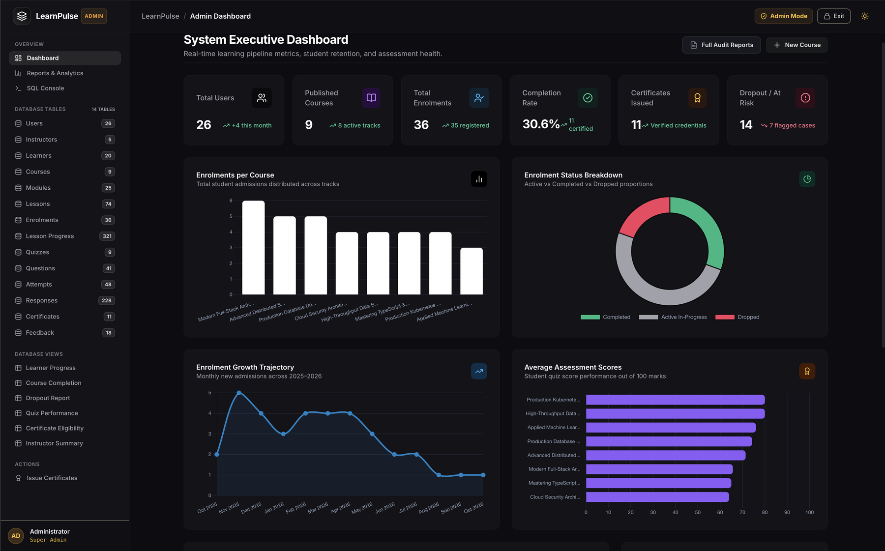
Figure 8. Admin mode: dashboard with KPI cards and charts
Figure 9 - Search, sort, filter, add, view, edit and delete rows of any of the 14 tables.
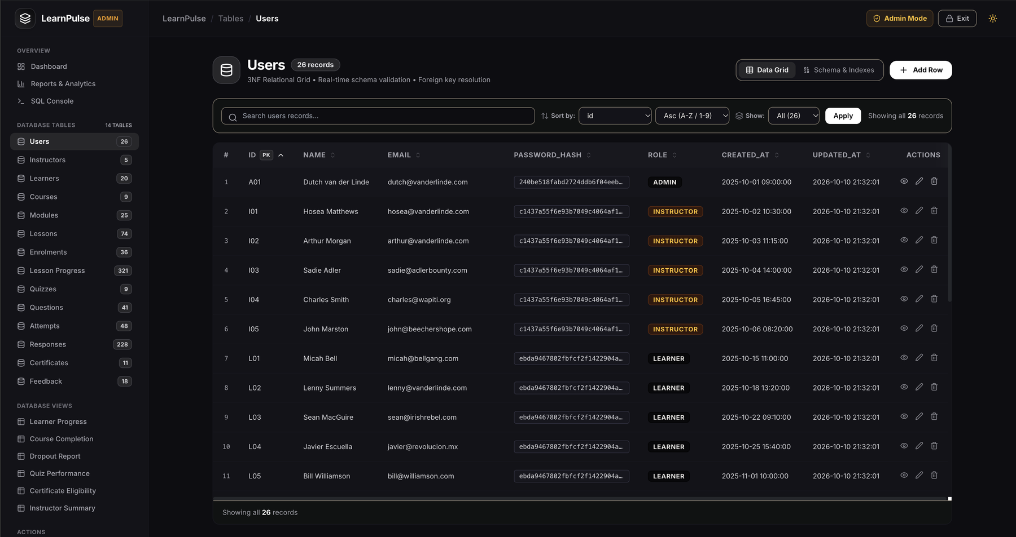
Figure 9. Admin mode: table browser with CRUD on the users table
Figure 10 - An empty required field is blocked with a message before anything reaches the database.
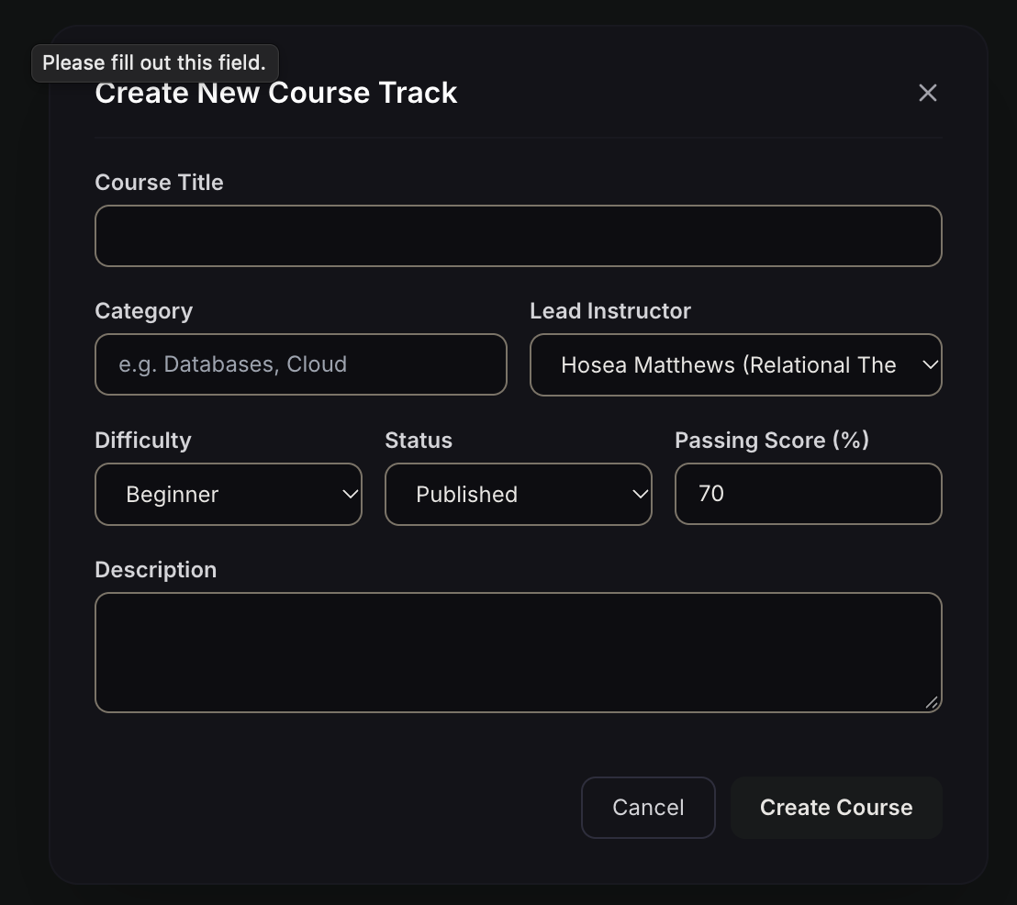
Figure 10. Admin mode: create course form with validation
Figure 11 - Six report tabs, each reading a SQL view, with CSV export.
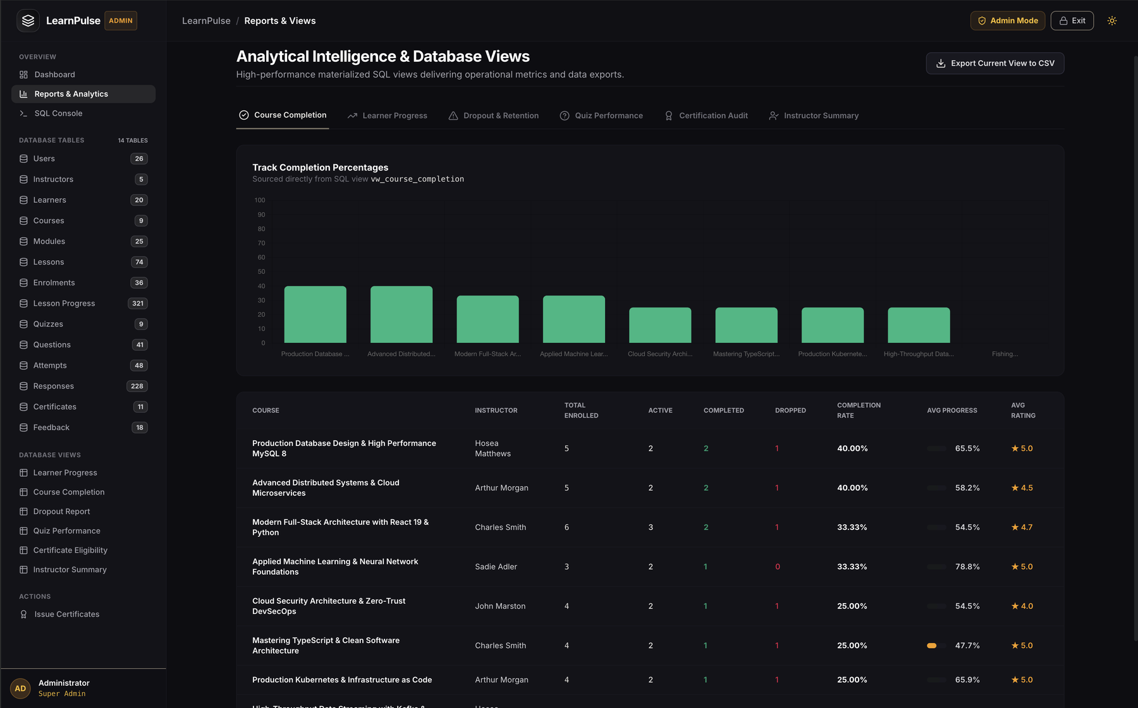
Figure 11. Admin mode: reports and analytics
Figure 12 - Only SELECT runs; DROP, ALTER, UPDATE and DELETE are rejected.
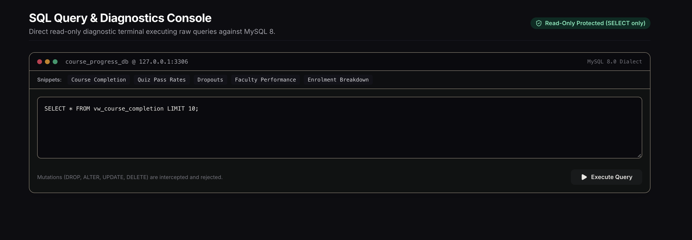
Figure 12. Admin mode: read-only SQL console
Figure 13 - Printable certificate with a unique verification code, for eligible learners only.
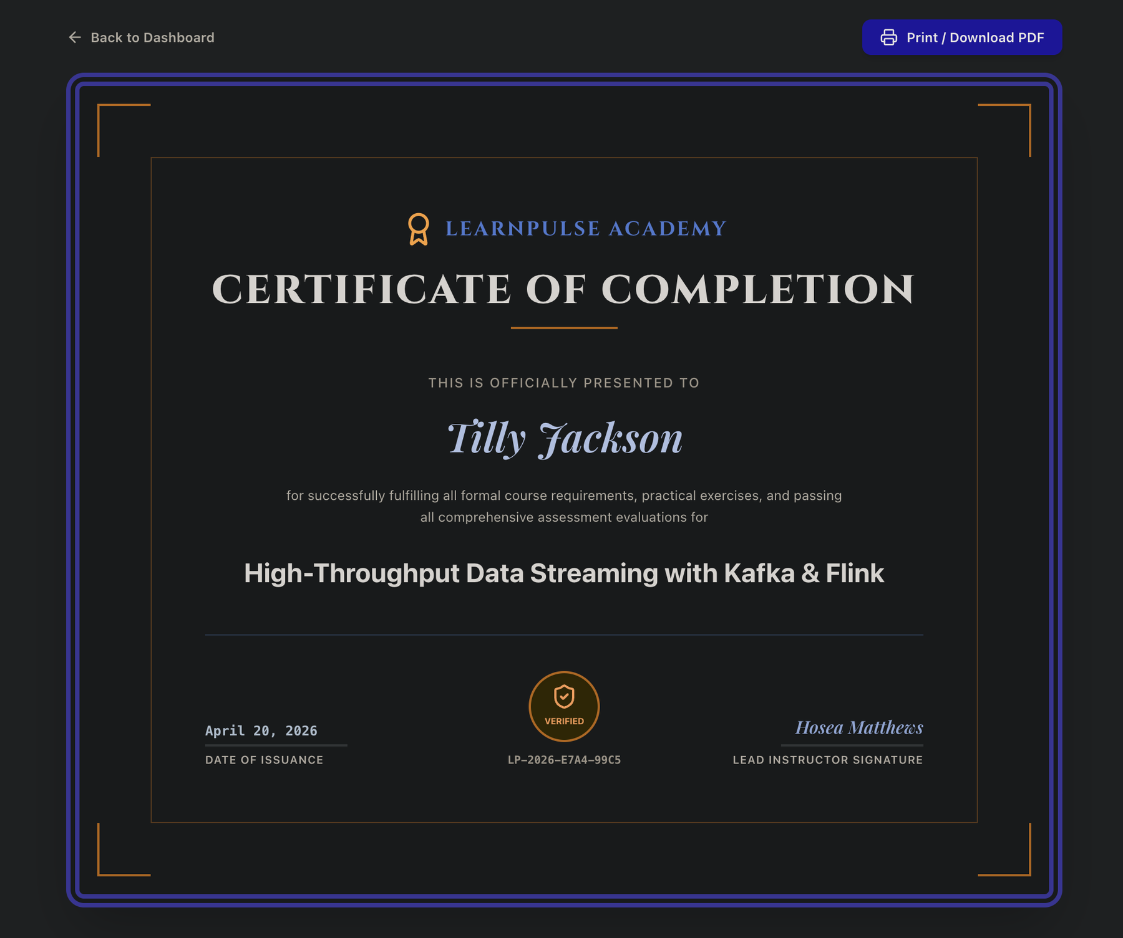
Figure 13. Admin mode: printable certificate of completion

3.8 Testing and Results
Table 17 lists the positive and negative test cases that were run on the application and the database.
Table 17. Test Cases
Test ID | Feature | Input / Action | Expected Result | Actual Result | Status
TC-01 | Enrolment | Enrol a learner in a published course not yet taken | Enrolment is created with status Active | Enrolment created; course appears in My Learning | Pass
TC-02 | Duplicate enrolment | Enrol the same learner in the same course again | Rejected with a clear message | Rejected; catalog shows 'Enrolled' | Pass
TC-03 | Progress range | Set lesson progress to 101 | Rejected by the CHECK constraint | Rejected by the CHECK constraint | Pass
TC-04 | Attempt limit | Make a 4th attempt on a quiz with 3 tries | Blocked by the trigger | Blocked by the trigger | Pass
TC-05 | Quiz score | Submit a quiz attempt within the limit | Attempt and responses saved; score calculated and not above total marks | Score stored and shown in reports | Pass
TC-06 | Early certificate | Issue a certificate before the course is completed | Blocked by the trigger | Blocked by the trigger | Pass
TC-07 | Certificate issue | Issue a certificate for a completed enrolment with all quizzes passed | Certificate created with a unique code and printable | Certificate listed in the registry with a verification code | Pass
TC-08 | Empty required field | Create a course with no title | Form asks to fill the field | Message shown; nothing saved | Pass
TC-09 | Unsafe SQL | Run DROP TABLE in the SQL console | Rejected, data unchanged | Rejected; data unchanged | Pass
TC-10 | Wrong admin password | Enter an incorrect password in the Unlock Admin dialog | Access denied | Access denied; Admin mode stays locked | Pass

All ten test cases, covering positive and negative paths, behaved as designed (Table 17). The duplicate enrolment, out-of-range progress, attempt limit and early certificate cases were stopped by the database itself through the UNIQUE, CHECK and trigger rules, which shows that the application cannot bypass the business rules. Form validation, the password checks and the read-only SQL console protected the application layer.
The tests also confirm that the application works against the designed database and not against static data: every screen reads and writes the shared MySQL tables, progress percentages are calculated in the database, and the reports are read from the six SQL views.

CHAPTER 4

CONCLUSION
This project addressed the problem that unstructured data makes learning progress unreliable. A normalized 3NF MySQL database of 14 tables was designed from an ER model and implemented with primary keys, foreign keys, UNIQUE, NOT NULL, CHECK and DEFAULT constraints, triggers, transactional stored procedures, indexes and six views, and was populated with 871 rows of realistic data.
A working Python Flask application was built on this database. Learners enrol and track progress, instructors publish content and quizzes, and administrators manage every table, run reports and issue certificates. The database itself enforces the key business rules, which the positive and negative tests confirmed. The project demonstrated normalization, data integrity, transaction awareness, indexing, input validation and systematic testing.

4.1 Limitations and Future Enhancements
- Replace the shared mode passwords with individual logins and hashed passwords (current limitation: the Instructor and Admin modes use shared passwords).
- Run the application on a production web server instead of the development server; it currently runs as a local application.
- Add quiz timers and question randomisation to make assessments more robust.
- Export reports to PDF in addition to CSV.
- Send e-mail alerts for certificates and dropouts.

REFERENCES
[1] R. Elmasri and S. B. Navathe, Fundamentals of Database Systems, 7th ed. Hoboken, NJ, USA: Pearson, 2016.
[2] A. Silberschatz, H. F. Korth, and S. Sudarshan, Database System Concepts, 7th ed. New York, NY, USA: McGraw-Hill, 2019.
[3] Oracle Corporation, MySQL 8.0 Reference Manual. Accessed: Oct. 11, 2026. [Online]. Available: https://dev.mysql.com/doc/refman/8.0/en/
[4] Pallets Projects, Flask Documentation. Accessed: Oct. 11, 2026. [Online]. Available: https://flask.palletsprojects.com/

APPENDICES

APPENDIX A - COMPLETE DATABASE SCRIPT
The complete database script (schema with constraints, indexes, triggers, stored procedures, views and sample data for course_progress_db) is submitted as a separate SQL file with this report. The representative queries used for the reports are given below.
A.1 Learner progress (JOIN)
SELECT l.name, c.title, e.status,
COUNT(lp.lesson_id) AS lessons_done
FROM enrolments e
JOIN learners l ON l.learner_id = e.learner_id
JOIN courses c ON c.course_id = e.course_id
LEFT JOIN lesson_progress lp
ON lp.enrolment_id = e.enrolment_id
AND lp.progress_pct = 100
GROUP BY e.enrolment_id, l.name, c.title, e.status;

A.2 Course completion rate (GROUP BY)
SELECT c.title,
COUNT(*) AS enrolled,
SUM(e.status = 'Completed') AS completed,
ROUND(100 * SUM(e.status = 'Completed')
/ COUNT(*), 1) AS completion_pct
FROM courses c
JOIN enrolments e ON e.course_id = c.course_id
GROUP BY c.course_id, c.title
HAVING COUNT(*) > 0;

A.3 Certificate eligibility (nested subquery)
SELECT e.enrolment_id, l.name, c.title
FROM enrolments e
JOIN learners l ON l.learner_id = e.learner_id
JOIN courses c ON c.course_id = e.course_id
WHERE e.status = 'Completed'
AND e.enrolment_id NOT IN
(SELECT enrolment_id FROM certificates)
AND NOT EXISTS (
SELECT 1 FROM quizzes q
WHERE q.course_id = e.course_id
AND NOT EXISTS (
SELECT 1 FROM attempts a
WHERE a.enrolment_id = e.enrolment_id
AND a.quiz_id = q.quiz_id
AND a.score >= q.pass_marks));

APPENDIX B - APPLICATION SOURCE CODE
The source code of the LearnPulse Flask application (routes for the Learner, Instructor and Admin modes, templates, static files and the start script) is submitted with this report. Repository: [GitHub / repository link]. Configuration (database login and mode passwords) is read from a .env file and is not stored in the page code.

APPENDIX C - ADDITIONAL TEST DATA AND OUTPUTS
Additional output screens that support Chapter 3 are given below. Final submission package: source code, database script, test data (871 rows across 14 tables), output screens, project report and viva notes (normalization, keys, triggers and ACID properties).
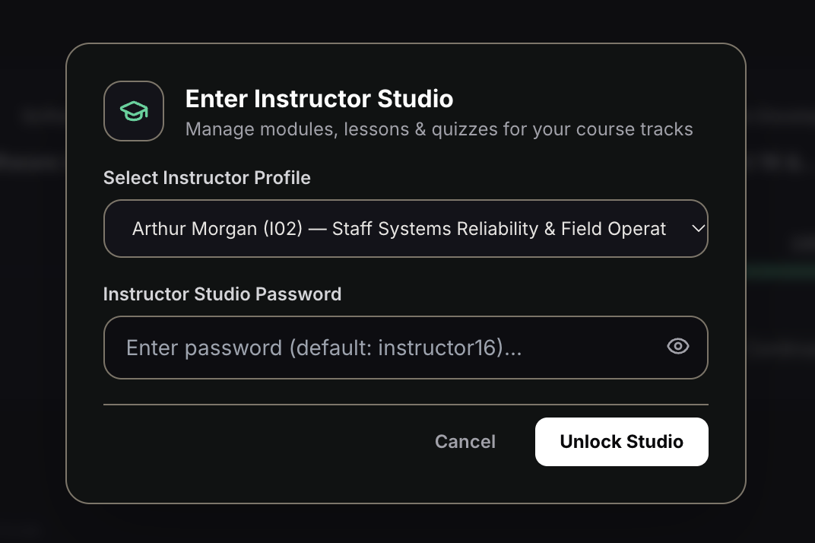
Figure 14. Instructor mode: studio unlock dialog (profile and password)
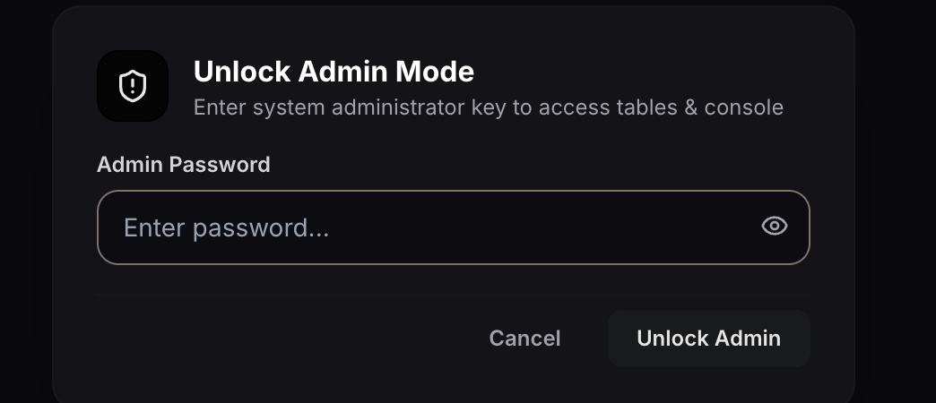
Figure 15. Admin mode: unlock dialog
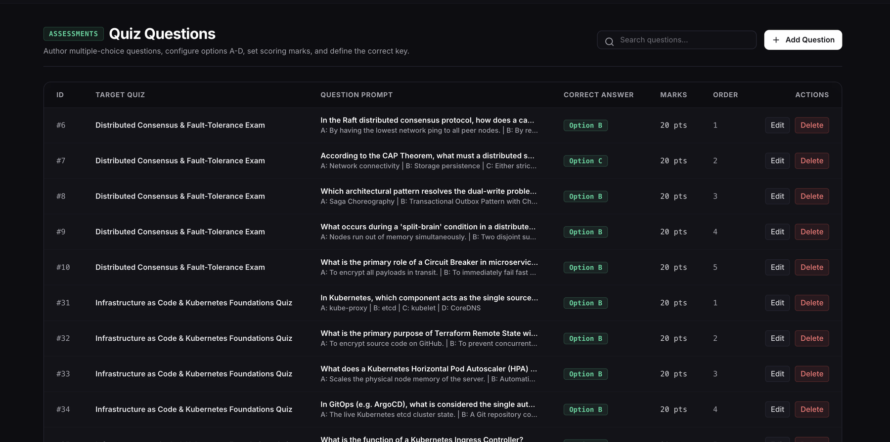
Figure 16. Instructor mode: quiz questions with options A to D and correct key
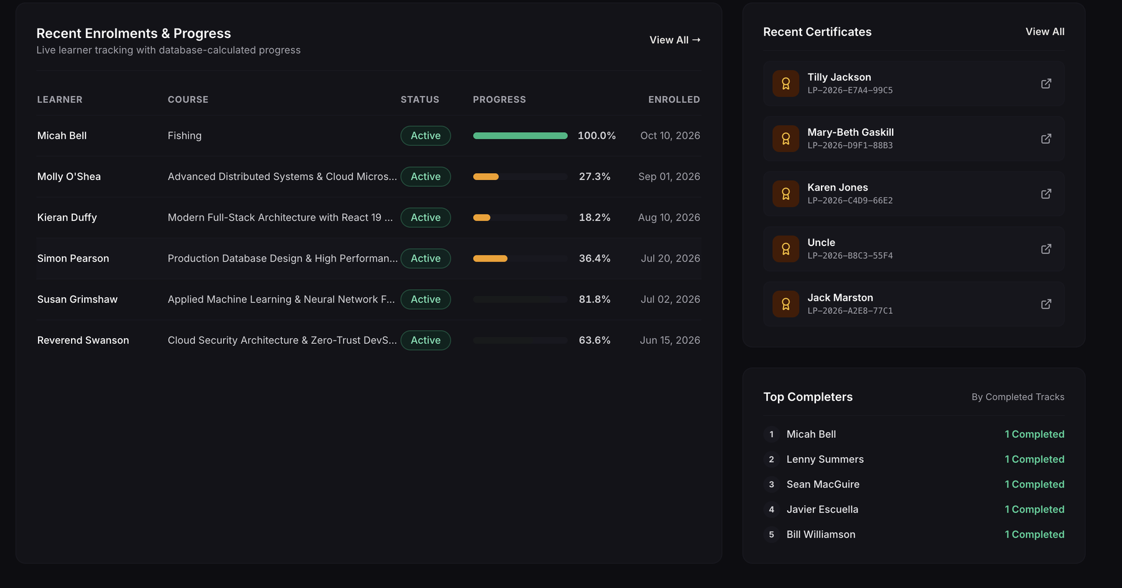
Figure 17. Admin mode: recent enrolments, certificates and top completers
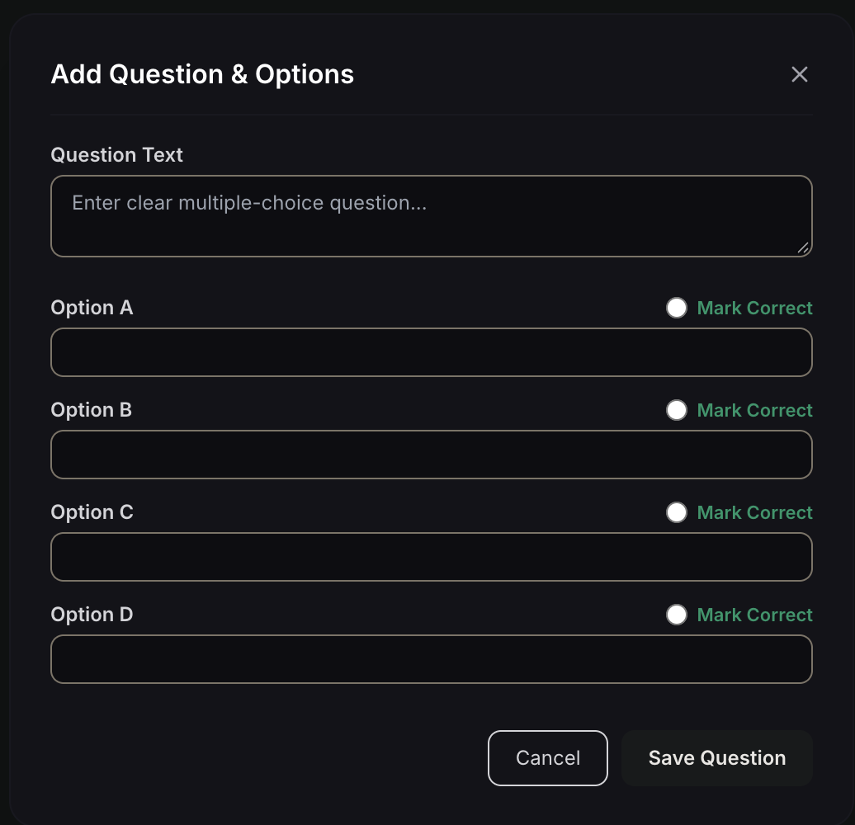
Figure 18. Admin mode: add question form with four options
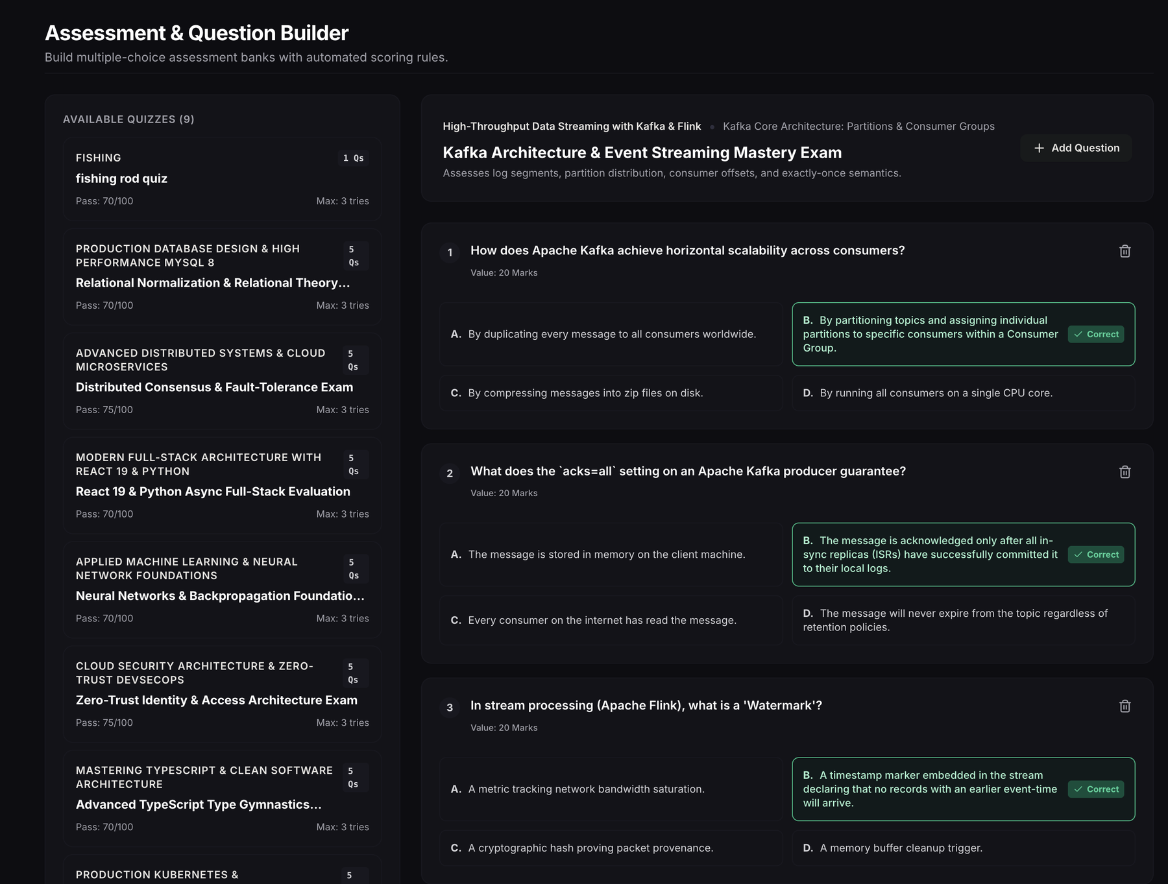
Figure 19. Admin mode: assessment and question builder
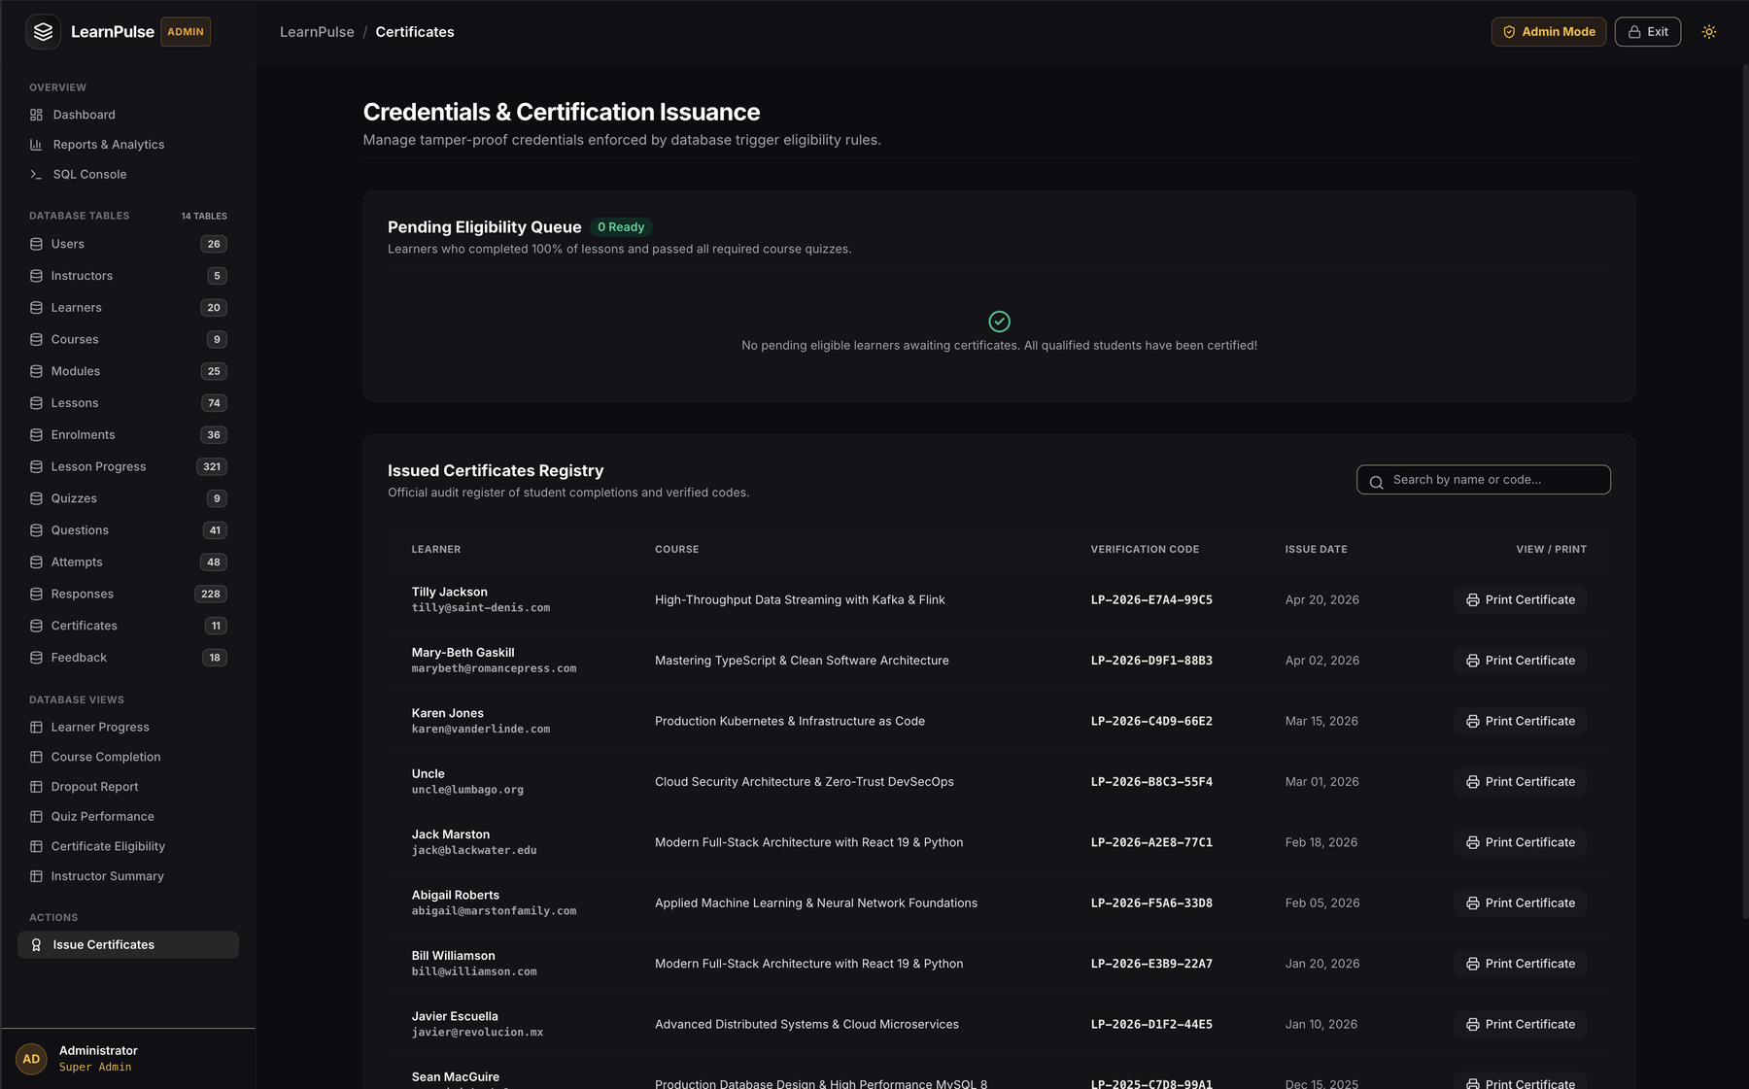
Figure 20. Admin mode: certificate registry with search and print

